**WEEK-3_EF Core 8.0_LAB4**

Lab 4:

Inserting Initial Data into the Database

Scenario:

The store manager wants to add initial product categories and products to the system. Objective:

Use EF Core to insert records using AddAsync and SaveChangesAsync.

Steps:

1. Insert Data in Program.cs:

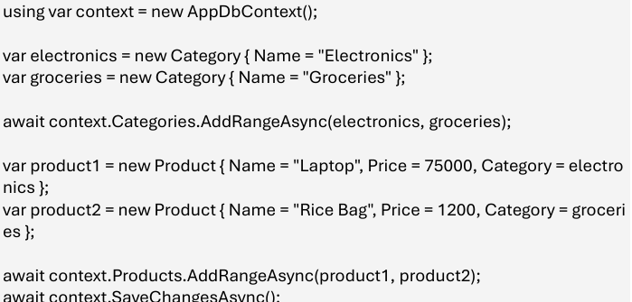

2.Run the App: dotnet run

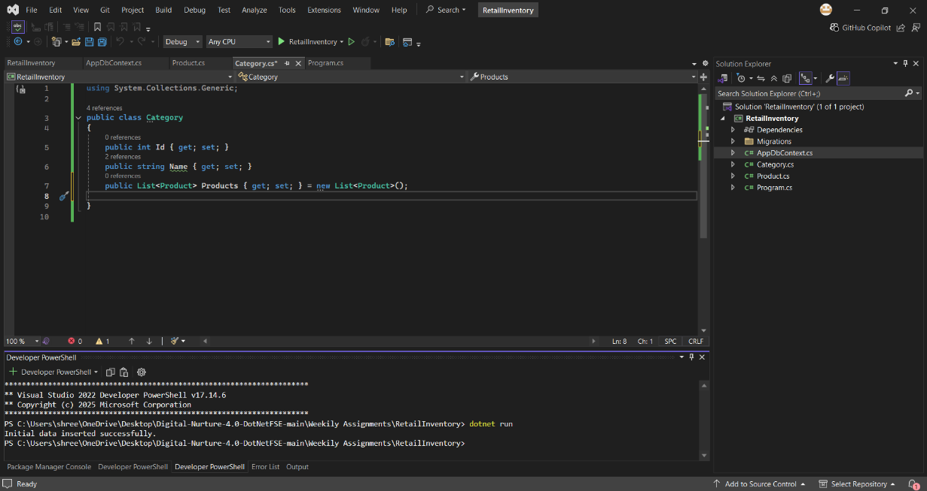

3.Verify in SQL Server: Check that the data is inserted correctly.

